# Introduction to Databases Exercise 3 Abhishek Maurya

*Problem Statement: There can be multiple customers, who can place multiple orders on the site. Now a sales person can handle these orders will distribute into multiple sales persons (One order will be assign to one salesperson only). So a sales person can have multiple orders of multiple customers.*

1. **Create Database**
   * create database testdb;

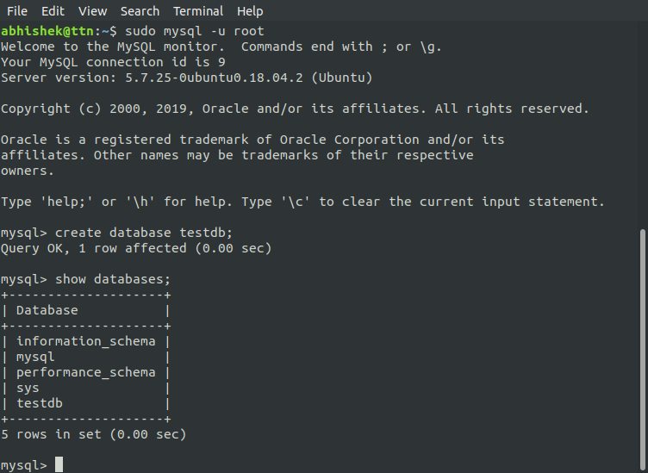

1. **Design Schema**

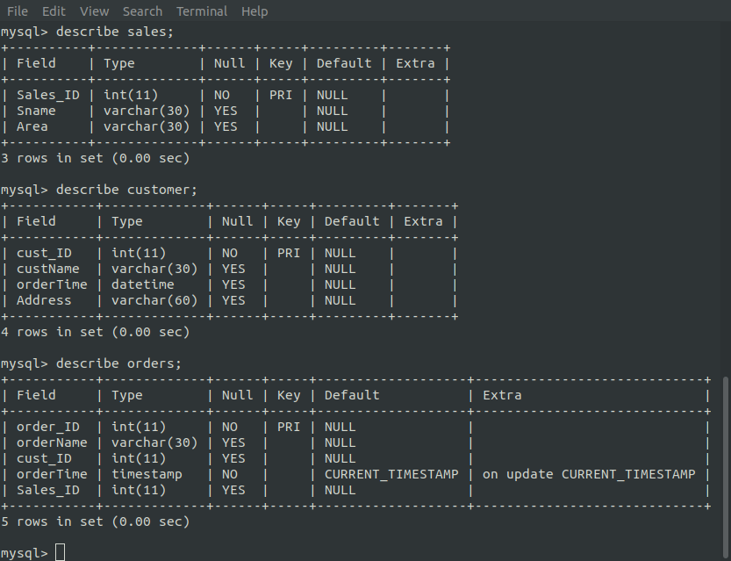

1. **Create tables** 
   * create table sales (Sales_ID int, Sname varchar(30), Area varchar(30), primary key(Sales_ID));
   * create table customer (cust_ID int, custName varchar(30), orderTime datetime, Address varchar(60), primary key(cust_ID));
   * create table orders (order_ID int not null, orderName varchar(30), cust_ID int, orderTime timestamp, Sales_ID int, primary key (order_ID));

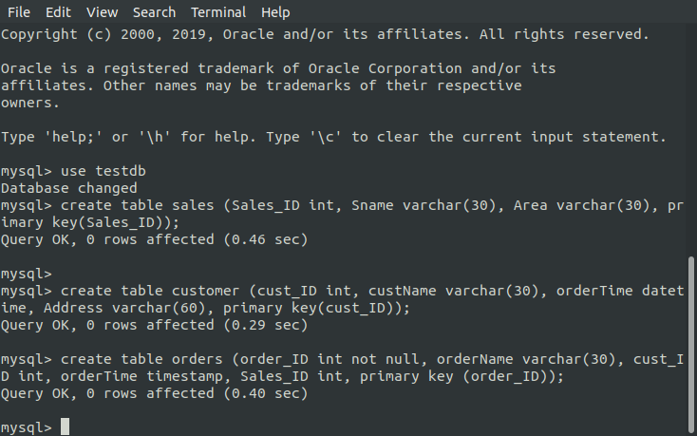

1. **Insert sample data**
   * insert into sales values(109,"Suresh Kumar","Sector 26");

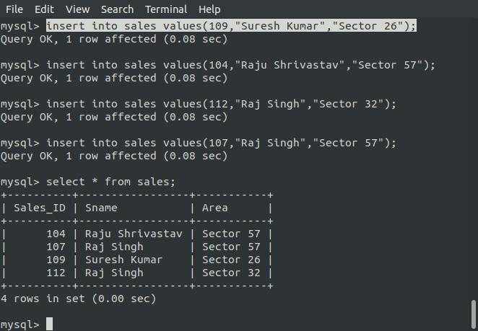

1. **Find the sales person have multiple orders.** 
   * select o.Sales_ID, s.Sname, count(o.order_ID) from sales s inner join orders o on o.Sales_ID=s.Sales_ID group by o.Sales_ID having count(order_ID)>1;

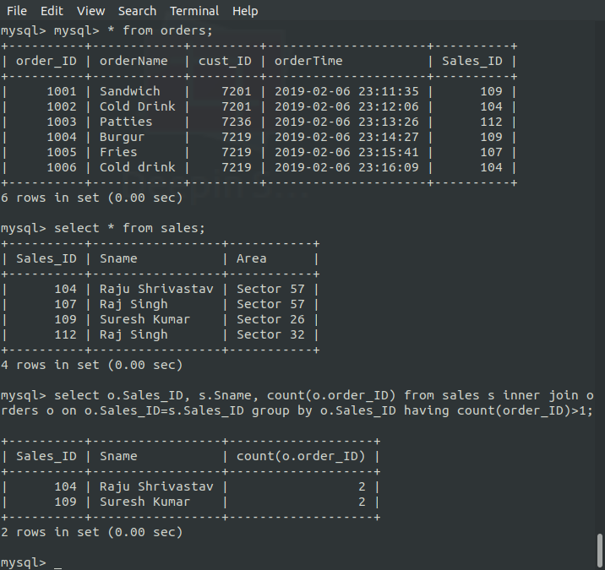

1. **Find the all sales person details along with order details**
   * select s.sname, s.Sales_ID, s.Area, o.order_ID, o.orderName from orders o inner join sales s on o.Sales_ID=s.Sales_ID order by s.sname;

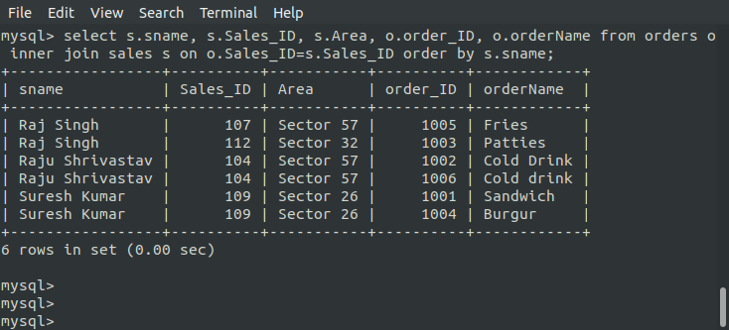

1. **Create index**
   * create index oid on orders (order_ID);

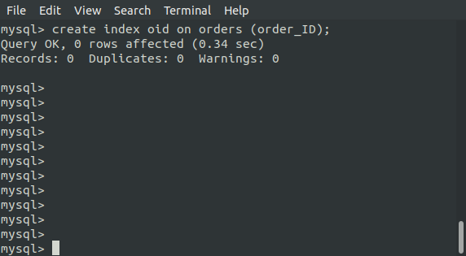

1. **How to show index on a table**
   * show index from others;

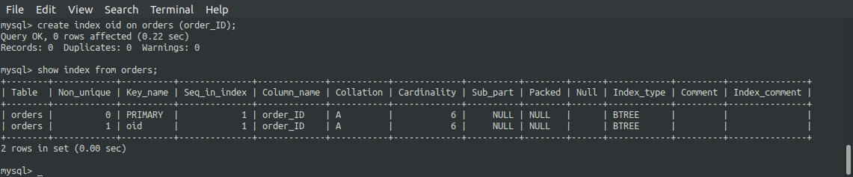

1. **Find the order number, salesperson name, along with the customer to whom that order belongs to**
   * select o.order_ID, s.sname, c.custName, o.orderName from orders o inner join sales s inner join customer c on o.Sales_ID=s.Sales_ID and o.cust_ID=c.cust_ID;

